

**Discovering Knowledge**

**FINAL YEAR PROJECT REPORT 2023**

**Brand-Fluence Network**

**Group Members**

|  |  |
| --- | --- |
| **Student Name** | **Enrolment#** |
| Muhammad Muaz Shahzad | 02-131202-081 |
| Talha Zafar | 02-131202-080 |
| Hassan Akhtar | 02-131202-019 |

**Supervised by**

Engr. Misbah Perveen

**Department of Software Engineering BAHRIA UNIVERSITY KARACHI CAMPUS**

**2. SOFTWARE PROJECT MANAGEMENT PLAN**

### Project Organization

Keeping a project organized and following a software process model provides structure when designing and building applications. A framework that outlines the tasks that need to be performed in each phase of software development. These steps allow developers to analyze the requirements. For organizing our Project, we will be using linear and structured progression. We use Waterfall Approach in Our FYP. In the context of waterfall software development, a structured and sequential approach is employed to manage and visualize the flow of work throughout the development process.

### Software Process Model

In this project, we will be utilizing the Waterfall development methodology, focusing on a structured and sequential approach to manage project progress. To track our advancements, we'll employ tools such as Gantt chart. Jira software will serve as our central platform for collaboration and progress monitoring.

The Waterfall model enables a methodical flow, allowing us to complete one phase before moving on to the next. This approach provides a clear structure for designing, coding, testing, and deployment. We aim to achieve project milestones, particularly in front-end and back-end development, with a systematic and thorough workflow. The number of iterations will be determined by the project requirements and internal evaluations post-initial deployment, ensuring that we achieve a robust and polished solution.

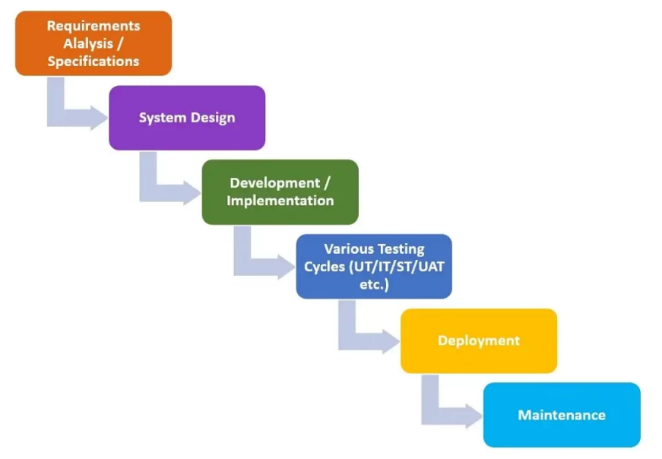

Figure1: Waterfall Development

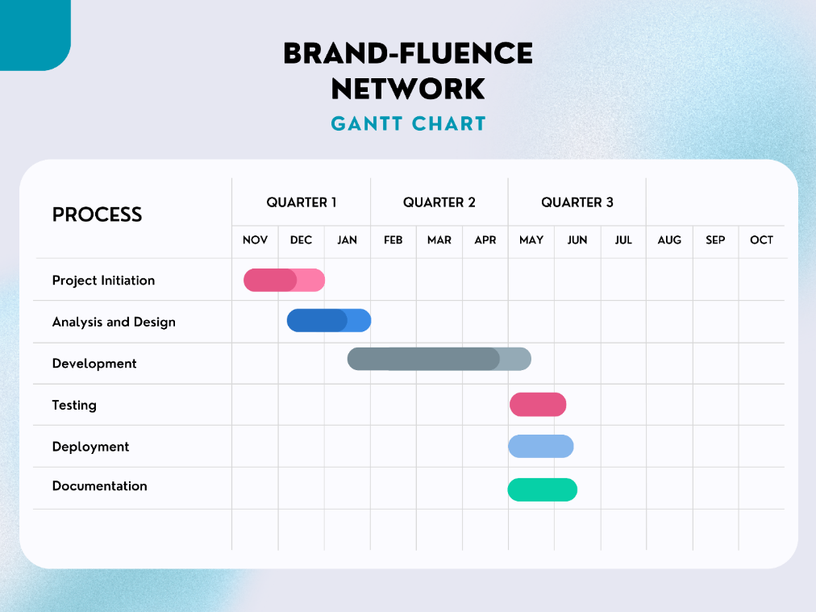

Figure 2: Gantt chart of Project

### Roles and Responsibilities

Brand-Fluence Network project is assigned to three members M Muaz Shahzad, Hassan Akhtar, Talha Zafar. Three members are responsible for the whole development of the software. We will use GitHub to store our code and use versioning tool to maintain different versions of software and we use Jira Software Tool for Monitoring and Controlling the Progress of our Project. All the documentation will be uploaded on Jira Tickets as well as google drive so that each member can access them anywhere and anytime.

|  |  |
| --- | --- |
| **Team Members** | **Role** |
| **M Muaz Shahzad** | Creating Backlog, Front-End & Back-End Development, Documentation, Monitoring |
| **Talha Zafar** | Designer, Front-End and Back-End Development, Documentation |
| **Hassan Akhtar** | Designer, Back-End Developer, Tester, Documentation |

### Tools and Techniques

### Front-End Tool:

* HTML, CSS & JavaScript.
* Tailwind CSS for responsiveness
* Bootstrap for responsiveness.
* React.js Library

### Back-End Tool:

* NoSQL Database Mongo DB.
* Node.js & Express js

### Other Languages and Testing Tool

* AI for train & display real time data.
* GitHub for version Control
* Jira for keeping track of the project.
* Selenium for Testing.

### Project Management Plan

### Tasks

There are some tasks involved in executing phases of projects. Some tasks are shown below:

* Requirement elicitation & analysis/Write SRS.
* Designing the system Prototype to get Feedback from Client. / Write the SDD.
* Implementation Version 1/ Development Version 1.

### Task-1

Create Software Requirements Specifications (SRS) BFN-32

### Description

Requirements will be compiled in meetings with our supervisor, who will communicate both functional and non-functional specifications. It is essential for our team to possess a comprehensive understanding of the project's objectives and intended audience. This collaborative process with the supervisor ensures clarity on what we are constructing and for whom, enabling the development of the project in accordance with expectations and optimizing outcomes.

### Deliverables and Milestones

* + - * + Software Requirement Specification (SRS)
        + Analysis Document

### Resources Needed

* + - * + Paper and Pen.
        + Existing software to get ideas.
        + Laptop for saving information.
        + Good Communication Skills.

### Dependencies and Constraints

Understanding the platform: Brands and influencers are encouraged to explore existing profiles and collaborations on the platform to gain insights into the look and feel of their products or partnerships.

Familiarity with Platform Terms: Both brands and influencers should acquaint themselves with platform-specific terms such as engagement metrics, collaboration fees, and profile details for effective communication and collaboration.

### Risks and Contingencies

In case of any hurdles in the project timeline, alternative strategies will be explored to ensure the timely completion of tasks, maintaining the project's progress.

### Task-2

Create Software Design Description (SDD) BFN-33

### Description

Now we will create a virtual architecture of whole system where we will depict number of modules, interfaces, API, database, and their relationships so that developer can get a clear picture of what he is going to build.

### Deliverables and Milestones

* + - * + Software Design Description (SDD)
        + Number Of Modules
        + Use Cases Diagram
        + Sequence Diagram
        + System Architecture Design.
        + Workflow Diagram
        + Programming Languages to be used.

### Resources Needed

* + - * + Software Requirement Specification (SRS)
        + Project team Collaboration
        + Laptop for creating documents.
        + Ms. Visio Software
        + Figma For Design a Prototype
        + Paper and Pencil to design document.

### Dependencies and Constraints

The SRS will serve as the foundation for crafting an accurate Software Design Document (SDD), and the collective expertise of our experienced developers will be pivotal in capturing and detailing the platform's functionalities and technical aspects.

### Risks and Contingencies

Change of requirements after requirement elicitation can lead to increase in time and cost as it disturbs the scope in triangle. Secondly important aspects are not properly written in a form of requirement is unable to create clear picture.

### Task-3

Implementation BFN-45

### Description

Developers will develop the designed software with the decided language. SDD will provide to developers during implementation. As we are following Waterfall methodology, we will go step by step.

### Deliverables and Milestones

* + - * + Developed modules.
        + Unit Testing report
        + Debugging reports
        + Status Reports

### Resources Needed

* + - * + Software Design Document (SDD)
        + Laptop/ desktop for programming
        + Communication methods.
        + Vs Code.

### Dependencies and Constraints

Programming skills are required to complete the task under cost and time constraints. Accurate and unambiguous software design documents are required to develop software as per decided quality.

### Risks and Contingencies

Vague SDD can lead to undesirable results. Secondly lack of skill can increase delivery time and increases cost.

### Assignments

For group projects, identify the assignment of team members to tasks.

|  |  |
| --- | --- |
| **Tasks** | **Performed By** |
| **Information gathering related to similar projects** | M Muaz Shahzad  Hassan Akhtar  Talha Zafar |
| **Defining Scope** | M Muaz Shahzad  Hassan Akhtar |
| **Communicator** | M Muaz Shahzad  Hassan Akhtar  Talha Zafar |
| **Software Requirement Specification** | M Muaz Shahzad |
| **Software Project Management Plan** | M Muaz Shahzad |
| **Software Design Document** | M Muaz Shahzad  Hassan Akhtar  Talha Zafar |
| **Front-End Development** | M Muaz Shahzad  Hassan Akhtar  Talha Zafar |
| **Back-End Development** | M Muaz Shahzad  Hassan Akhtar  Talha Zafar |
| **Use Case Diagram** | Talha Zafar |
| **Sequence Diagram** | Talha Zafar |
| **Work Breakdown Diagram** | Talha Zafar |
| **Workflow Diagram** | M Muaz Shahzad |
| **Architectural Diagram** | M Muaz Shahzad |
| **Unit Testing** | M Muaz Shahzad  Hassan Akhtar  Talha Zafar |
| **User Acceptance Testing** | Hassan Akhtar |
| **Report Formation** | M Muaz Shahzad  Talha Zafar |
| **Quality Assurance** | M Muaz Shahzad |
| **Research & Development** | M Muaz Shahzad  Hassan Akhtar  Talha Zafar |

### Timetable

Figure 4: Table

Figure 5: Gantt Chart